**ANDROMEDA USER MANUAL**

**Project Andromeda Documentation:**

Overview:

* This Section covers how the project and its components creation. It describes the initial setup, tools, technologies, and processes involved.
* The Andromeda project was initiated to address the need for the automotive creation of parts, part control and different part specification. The initial setup involved Java, Rest-Webservices, PostgreSQL as the database. Key modules created includes the creation of Part, Part control and part specification and control management.

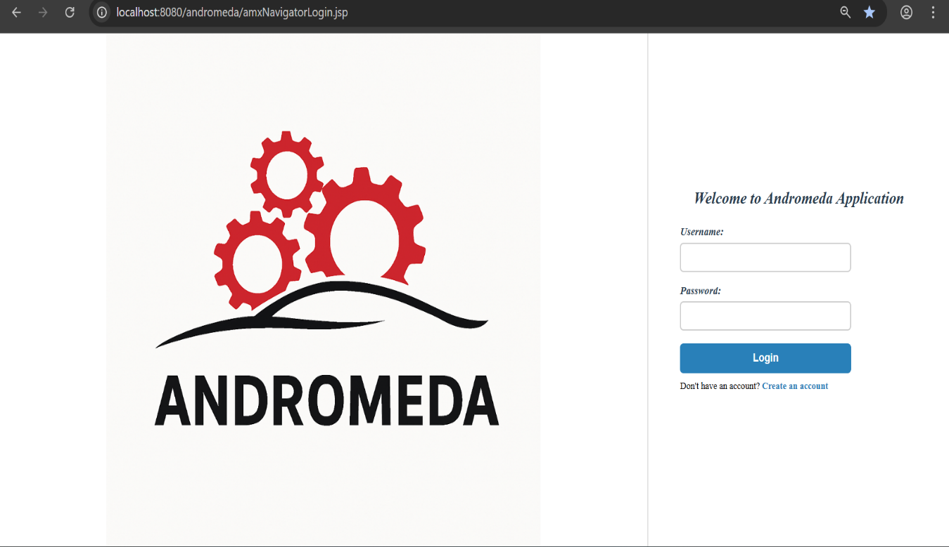This is the overview of the Andromeda UI